Agenda Item : 1/01

= application site



Clavering Nursing Home, Royston Grove | P/2344/18

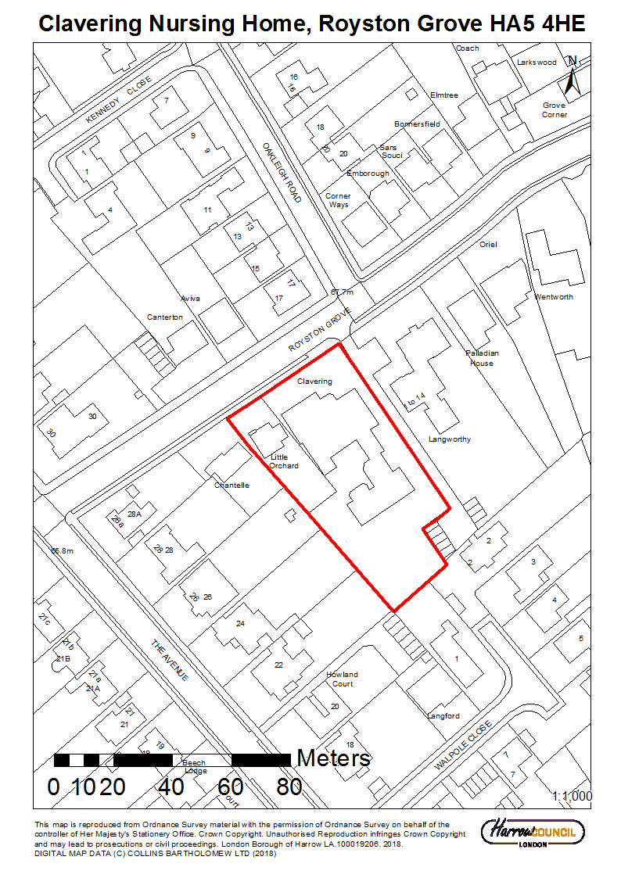

LONDON BOROUGH OF HARROW

PLANNING COMMITTEE

21 September 2018

Application Number: | P/2344/18
Validate Date: | 5th June 2018
Location: | CLAVERING NURSING HOME, ROYSTON GROVE, PINNER
Ward: | HATCH END
Postcode: | HA5 4HE
Applicant: | TLC GROUP LTD
Agent: | RICHARD HENLEY
Case Officer: | CATRIONA COOKE
Expiry Date: | 31/08/2018 (extended 30 November 2018)

PROPOSAL

Redevelopment to provide a three storey building with basement for Care home (Class C2) with staff accommodation; Amenity space; Parking and Landscaping; Cycle and Refuse storage

RECOMMENDATION

The Planning Committee is asked to:

- agree the reasons for approval as set out in this report, and

- grant planning permission subject to to the conditions (set out in Appendix 1 of this report).

REASON FOR THE RECOMMENDATIONS

The existing Clavering nursing home site is no longer adaptable or able to meet current demands for Extra Care housing. The development is in keeping with the area. Additionally, it has been found that there would be no detrimental impacts on the amenity of surrounding neighbouring occupiers or any adverse highways impacts arising from the development. The development would result in landscape and ecological enhancements and would contribute towards the strategic objectives of reducing carbon reductions in the borough.

INFORMATION

This application is reported to Planning Committee as it is a Major Development and therefore falls outside Schedule 1 of the Scheme of Delegation.

Statutory Return Type: | Major Development
Council Interest: | None
GLA Community Infrastructure Levy (CIL) Contribution (provisional): | 3185 x 35 = £111,475
Local CIL requirement: | 3185 x 110 = £350,305
S17 Crime & Disorder Act

Policies 7.3.B and 7.13.B of The London Plan (2016) and Policy DM1 of the Development Management Polices Local Plan require all new developments to have regard to safety and the measures to reduce crime in the design of development proposal. It is considered that the development does not adversely affect crime risk.

LOCAL GOVERNMENT (ACCESS TO INFORMATION) ACT 1985
BACKGROUND PAPERS USED IN PREPARING THIS REPORT:

- Planning Application
- Statutory Register of Planning Decisions
- Correspondence with Adjoining Occupiers
- Correspondence with Statutory Bodies
- Correspondence with other Council Departments
- Nation Planning Policy Framework
- London Plan
- Local Plan - Core Strategy, Development Management Policies, SPGs
- Other relevant guidance

LIST OF ENCLOSURES / APPENDICES:

Officer Report:
Part 1: Planning Application Fact Sheet
Part 2: Officer Assessment
Appendix 1 – Conditions and Informatives
OFFICER REPORT

PART 1: Planning Application Fact Sheet

The Site

Address | Clavering Nursing Home and Little Orchard  Royston Grove, Pinner. HA5 4HE
Applicant | TLC GROUP LTD
Ward | HATCH END
Local Plan allocation | Core Strategy Sub Area – Pinner and Hatch End;  Critical Drainage Area;  RAF Northolt Safeguarding Zones
Conservation Area | N/A
Listed Building | N/A
Setting of Listed Building | N/A
Building of Local Interest | N/A
Tree Preservation Order | Individual TPOs
Other | N/A

Housing

Density | Proposed Density hr/ha | n/a
Density | Proposed Density u/ph | n/a
Density | PTAL | 1a / 2
Density | London Plan Density Range | n/a
Dwelling Mix | Studio (no. / %) | -
Dwelling Mix | 1 bed ( no. / %) | -
Dwelling Mix | 2 bed ( no. / %) | -
Dwelling Mix | 3 bed ( no. / %) | -
Dwelling Mix | 4 bed ( no. / %) | -
Dwelling Mix | Overall % of Affordable Housing | -
Dwelling Mix | Social Rent (no. / %) | -
Dwelling Mix | Intermediate (no. / %) | -
Dwelling Mix | Private (no. / %) | -
Dwelling Mix | Commuted Sum | -
Dwelling Mix | Comply with London Housing SPG? | YES
Dwelling Mix | Comply with London Housing SPG? | YES
Dwelling Mix | Comply with M4(2) of Building Regulations? | YES

Non-residential Uses

Existing Use(s) | Previous / Existing Use / Operator | Former Nursing Home and Adjacent Dwellinghouse / TLC Group Ltd
Existing Use(s) | Existing Use Class(es) sqm | Class C2 (nursing home) and Class C3 (dwellinghouse)
Proposed Use(s) | Proposed Use / Operator | Respite, nursing and dementia care home / TLC Group Ltd
Proposed Use(s) | Proposed Use Class(es) sqm | Class C2 and ancillary nursing staff accommodation
Employment | Existing number of jobs | Nil (vacant)
Employment | Proposed number of jobs | 62 (FTE)

Transportation

Car parking | No. Existing Car Parking spaces | 16
Car parking | No. Proposed Car Parking spaces | 16
Car parking | Proposed Parking Ratio | 0.2
Cycle Parking | No. Existing Cycle Parking spaces | 0
Cycle Parking | No. Proposed Cycle Parking spaces | 10
Cycle Parking | Cycle Parking Ratio | 0.13
Public Transport | PTAL Rating | 1a / 2
Public Transport | Closest Rail Station / Distance (m) | 600
Public Transport | Bus Routes | H12, H14 & 186
Parking Controls | Controlled Parking Zone? | No
Parking Controls | CPZ Hours | n/a
Parking Controls | Previous CPZ Consultation (if not in a CPZ) | n/a
Parking Controls | Other on-street controls | none

Parking Stress | Area/streets of parking stress survey | No
Parking Stress | Dates/times of parking stress survey | Survey Not Undertaken nor requested.
Highways |  | Highways Officer Support for the Application.  The proposed care home will generate ten vehicle trips in the AM & PM peak  periods. The net increase over the former home will be only three to four trips. This will have minimal impact on the local streets.
Refuse/Recycling Collection | Summary of proposed refuse/recycling strategy | Proposed refuse and recycling store (ground floor)  Proposed 8No. 1100 litre & 6No 240 litre bins.  Council general refuse / recycling / green waste - collection roadside (as previous).  Clinical waste collection private contractor.

Sustainability / Energy

BREEAM Rating
Development complies with Part L 2013?
Renewable Energy Source / % | to reduce on-site regulated carbon emissions by approximately 36% with energy efficient measures including the use of solar PV, high efficiency boilers etc

PART 2: Assessment

- SITE DESCRIPTION

  - The application site relates to an irregular shaped plot of land which measures 0.322 ha in area, located on the south eastern side of Royston Grove, a residential street of mixed character. The site is occupied by the redundant Clavering Care home which has approval for demolition and a dwelling house “Little Orchard.

  - To the north east of the site is Langworthy, a three storey flatted development containing 14 flats and to the south west is High Hedges a two storey detached dwellinghouse and the rear boundaries of 22 to 26 The Avenue.

  - The site is located in a predominantly residential area with a Ptal rating of 1a (poor) with Hatch End station approximately 9 minutes’ walk away.

- PROPOSAL

  - The proposal is for the redevelopment of the site, comprising a 2 storey building with a basement to accommodate a 76 room Care Home (Use Class C2) including communal lounges; ancillary offices; cinema; spa; staff accommodation cycle, refuse and stores; 16 car parking spaces.

  - The proposal would be 2 storeys plus a lower ground floor and accommodation in the roofspace. The building would have a pitched roof design with a front gable and front dormers with a grey clay tile finish. The external wall would be comprised of red facing brick work and powder coated aluminium windows and doors.

- RELEVANT PLANNING HISTORY

  - P/1534/16
Application For Prior Approval Of Proposed Demolition Of Clavering Nursing Home
Prior Approval Not Required

- CONSULTATION

  - Five Site Notices were erected on 11th July 2018 expiring on 2nd August 2018.

  - Press Notice was advertised in the Harrow Times on the 7th June 2018 expiring on 28th June 2018.

  - The application was advertised for the following reasons:

- Major application.

  - A total of 58 consultation letters were sent to neighbouring properties regarding this application.

  - The overall public consultation period expired on 26th June 2018.

  - Adjoining Properties

Number of letters Sent | 58
Number of Responses Received | 7
Number in Support | 0
Number of Objections (including petition from the residents of Rectory Close with 6 signatures) | 7
Number of other Representations (neither objecting or supporting) | 0

  - A summary of the responses received along with the Officer comments are set out below:

Summary of Comments | Officer Comments
Concern with disturbance during construction phase. | Not a material planning consideration
Traffic Issues – during construction and once operating. | This is discussed in section 6.5 – 6.5.6
Too large - Out of keeping with the locality | This is discussd in section 6.3-6.3.9
Concern relating to excavation for the proposed basement | Not a material planning consideration
Loss of outlook – proposal larger and closer to the boundary with neighbouring properties. | This is discussed in section 6.4-6.4.9

  - Following amendments to the scheme local residents were re-notified on 29th October expiring on 19th November 2018.

  - Consultation

  - A summary of the consultation responses received along with the Officer comments are set out in the Table below.

Consultee | Summary of Comments | Officer Comments
Arboricultural Officer | No objections. | Noted.
LBH Landscape Architect | No objections
LBH Highways | No objection subject to further details to be submitted | Noted.
LBH Drainage | No objection subject to conditions | Noted.
LBH Biodiversity Officer | Notwithstanding any approval, the following should be applied as Conditions:  (1) Bats  a) In full accordance with the prescriptions of the outline bat mitigation strategy (RT-MME-128834-01 Rev A):  - Harm to bats to be avoided during both the preparations for and the demolition of the existing buildings;  - Should any bat be encountered in the buildings in the course of demolition, such works are to be halted until guidance from a suitably qualified ecologist has been sought and enacted  - 6 Habibat boxes to be installed within the fabric of the new building in the locations indicated in plan C128834-0101;  - 6 Schwegler 2F(DFP) boxes to be installed in appropriate locations on suitable trees – location details to be provided for approval.  b) In accordance with current best practice guidance and the recommendations of the outline strategy, for as long as the proposed development shall remain, any external lighting installations, should be so designed as to minimise impacts on wildlife, especially the commuting and foraging behaviours of bats, and the crepuscular or nocturnal activities of invertebrates, both within and along the margins at the site. In particular there should be no direct illumination of any shelters for bats whether in/on vegetation or artificial structures.  (2) Birds  a) Birds of all species are protected from disturbance whilst breeding. Ideally anyl works liable to cause disturbance to nesting birds should ideally be undertaken outside the main bird breeding season - which runs from March to September inclusive. Where this will not be feasible, a suitably qualified ecologist will undertake a search for the presence of nesting birds no more than a day prior to the commencement of demolition/construction works and a buffer of 5+ metres (as appropriate to the sensitivity of the species in question) shall be left around any active nest location. The applicant is advised that collard dove and wood pigeon may breed all year round and that likely nesting locations which could impede development if occupied should be blocked off or removed during October-February. Should an active nest be found within the buffer zone around the new building footprint once construction has commenced, all work in that area should be halted until advice from a suitably qualified ecologist has been sought and implemented.  b) Two Schwegler 2H open-fronted bird nest boxes and 2+ Schwegler 2GR nest boxes (One with 26 mm and one with 30mm entrance hole to be installed in trees or on buildings where appropriate locations would enable residents to watch nesting birds without causing them disturbance) [The 2GR design is specified in preference to the 1B given the likely presence of cats on the site]  (3) Invertebrates  a) 2+ Log piles/loggeries to be created. Different situations (e.g. one shaded, one partially shaded only) should be selected where possible. Plans for the sites management should include topping these up with additional logs using the same locations over time  b) 2 artificial invertebrate shelters to be provided  (4) Hedgehog and other small vertebrates  a. Care to be taken during demolition and construction. Any holes or ditches which form part of the construction works to be left covered overnight or provided with boards or similar to enable animals to extricate themselves easily;  b. Access points to be created in any fences (where safe access ways are otherwise not provided) to enable hedgehogs and other small vertebrates access to and from the site.  (5) Water feature  The proposed water feature, to be of a type that will provide both different habitat and a safe source of water for animal species – details to be provided for approval. [Details were lacking when provided information was last reviewed].]  (6) Ongoing management and monitoring  The applicant shall provide a plan for approval which in addition to outlining how the points above will be addressed (where not already detailed), will also set out how ongoing management and maintenance works and necessary monitoring will be undertaken so as to provide a clear guide to whichever parties will be conducting these works and ensure that planned gains in biodiversity value ( including via new landscaping and planting programme) will be delivered and maintained.  Reasons  In order to protect and enhance biodiversity in accordance with Harrow policies DM20 and DM21, the wider requirements of the London Plan, the National Planning Policy Framework and relevant wildlife legislation.  Informative  The applicant should be encouraged to consider providing bird feeding stations of different types around the site, in addition to providing extra forage for a range of species this would also provide ready access to nature for the residents from their accommodation or whilst in the garden.  Applicant to be encouraged to provide more ‘invertebrate bricks’ to be built into SE-SW facing walls, providing shelter for a range of species likely to be attracted by the plantings.  Selecting a permanent site for compost heaps will have added wildlife value  Prunings from trees and shrubs may also make valuable brash piles, especially in sunny situations, and where brambles may be permitted to overgrow the piles  It is considered that the above will overall add lasting value for biodiversity – and should also give added value for residents | Noted.

- POLICIES

  - Section 38(6) of the Planning and Compulsory Purchase Act 2004 requires that:

  - ‘If regard is to be had to the Development Plan for the purpose of any determination to be made under the Planning Acts, the determination must be made in accordance with the Plan unless material considerations indicate otherwise.’

  - The Government has issued the National Planning Policy Framework [NPPF] which consolidates national planning policy and is a material consideration in the determination of this application.

  - In this instance, the Development Plan comprises The London Plan 2016 [LP], the Draft London Plan (2017) and the Local Development Framework [LDF]. The LDF comprises The Harrow Core Strategy 2012 [CS], Harrow and Wealdstone Area Action Plan 2013 [AAP], the Development Management Policies Local Plan 2013 [DMP], the Site Allocations Local Plan [SALP] 2013 and Harrow Local Area Map 2013 [LAP].

  - The Draft new London Plan was published on 29th November 2017. Given, that the draft Plan is still at early stages of the formal process it holds very limited weight in the determination of planning applications. Although this weight will increase as the Draft London Plan progresses to examination in public stage and beyond, applications would continue to be determined in accordance with the 2016 London Plan. It is anticipated that the Examination in Public will commence early 2019.

  - Notwithstanding the above, the Draft London Plan (2017) remains a material planning consideration, with relevant polices referenced within the report below and a summary within Informative 1.

  - A full list of all the policies used in the consideration of this application is provided as Informative 1 in Appendix 1 of this report.

- ASSESSMENT

- Principle of the Development
- Affordable Housing and Housing Mix
- Character and Appearance
- Residential Amenity and Accessibility
- Traffic, Parking and Drainage
- Biodiversity
- Energy and Sustainability
- Environmental Impact Assessment

  - Principle of Development

Provision of Care Facilities including Extra Care Accommodation

6.1.1 Paragraph 61 of the National Planning Policy Framework (2018) outlines that “
“… the size, type and tenure of housing needed for different groups in the community should be assessed and reflected in planning policies (including, but not limited to, those who require affordable housing, families with children, older people, students, people with disabilities, service families, travellers, people who rent their homes and people wishing to commission or build their own homes).”

6.1.2 London Plan policy (2016) 3.16 outlines the need for additional and enhanced social infrastructure provision to meet the needs of its growing and diverse population. It states that “development proposals which provide high quality social infrastructure will be supported in light of local and strategic needs assessments…Facilities should be accessible to all sections of the community and be located within easy reach by walking, cycling and public transport”. Further to this, 3.17 ‘Health and Social Care Facilities states that “proposals that provide high quality health and social care facilities will be supported in areas of identified need, particularly in places easily accessible by public transport , cycling and walking”.

6.1.3 The London Plan (2016) also identifies a need for specialist accommodation for older people (including sheltered accommodation, extra care accommodation and nursing home care). Paragraph 3.50b states:

“Research suggests that the choices open to older Londoners to move into local specialist housing may have been constrained through inadequate supply. Extending these choices through a higher level of specialist provision will in turn free up larger family homes for family occupation. Over the period 2015-2025, older Londoners may require 3,600-4,200 new specialist units per annum. At the mid-point of this range, these might be broken down broadly into 2,600 private units pa, 1000 in shared ownership and some 300 new affordable units. There may also be a requirement for 400-500 new bed spaces per annum in care homes”

6.1.4 Table A5.1 of The London Plan provides indicative strategic benchmarks to inform local targets and performance indicators for specialist housing for older people (including sheltered accommodation, extra care accommodation and nursing home care) between 2015 and 2025. The annual benchmark figure for Harrow is stated as 150 units.

6.1.5 Local plan policy DM 29 states that “the Council will support proposals on previously developed land for sheltered housing, care homes and extra care housing (across all tenures) for older people and those who may be vulnerable, provided that the proposal is accessible by public transport with good access to local amenities including shops and local facilities”.

6.1.6 Policy 3.14 of the London Plan (2016) resists the loss of existing housing. The proposed development will result in the loss one dwellinghouse. However, given that the proposal would create housing albeit in a difference form it is considered that the loss of one residential unit can be supported in this instance.

6.1.7 The policies outlined above provide support in principle for the provision of a care home, of any typology, at this location and within the borough. The proposal would provide for a meaningful contribution both towards the housing target and also a type of sheltered housing, and therefore the proposal is considered to be acceptable in principle.

6.2 Affordable Housing

6.2.1 Core Policy CS1J of the Harrow Core Strategy (2012) seeks the maximum reasonable amount of affordable housing on all development sites, with a Borough-wide target of 40%. DM policy DM 24 states that proposals that secure an appropriate mix of housing on site and which contribute to the creation of mixed and inclusive communities will be supported.

6.2.2 Paragraph 6.30 outlines that policy CS1 J applies to schemes for sheltered housing and extra care homes that fall within the thresholds. It goes onto say at paragraph 6.31 that “Residential care homes and nursing homes, where the accommodation is non-self-contained, fall within use Class C2 (Residential Institutions) and are not subject to the affordable housing policy”.

6.2.3 The 76 bedrooms for the residents contain a bathroom. There are large communal living rooms and dining rooms on each floor. Therefore the units are not considered to be self-contained units and therefore fall wholly within a C2 use Class. 4 flats would also be provided for staff which are considered to be ancillary to the overall C2 use. The proposal would therefore comply with Policy CS1 J and is not subject to affordable housing.

6.3 Character and Appearance

Scale, Mass and Layout

6.3.1 As outlined in paragraphs 124 to 131 of the NPPF (2018), The Government attaches great importance to the design of the built environment. Good design is a key aspect of sustainable development, is indivisible from good planning, and should contribute positively to making places better for people. It is important to plan positively for the achievement of high quality and inclusive design for all development, including individual buildings, public and private spaces and wider area development schemes.

6.3.2 Policy 7.4 (B) of the London Plan requires that buildings, streets and open spaces should provide a high quality design response that has regard to the pattern and grain of the existing spaces and streets in orientation, scale, proportion and mass. Policy 7.6 of the London Plan (2016) outlines that architecture should make a positive contribution to a coherent public realm, streetscape and wider cityscape. It should incorporate the widest quality materials and design it appropriate to its context. Buildings should have complimentary building materials, be of a proportion, composition, scale and orientation which enhances and defines the public realm.

    - The above design considerations are echoed in Draft London Plan (2017) Policy D1. This requires that development design should respond “to local context by delivering buildings and spaces that are positioned and of a scale, appearance and shape that responds successfully to the identity and character of the locality, including to existing and emerging street hierarchy, building types forms.

    - The existing Clavering Nursing Home is 2 storeys high and has had many unsympathetic additions to the original property. The scheme proposes some excavation to allow for the basement element containing 4 staff flats, ancillary services, cinema and a space area for residents.

    - The proposed two storey building is considered to be appropriate in the surrounding context. Following initial concerns raised by the Councils Urban Design officer in relation to the scale and mass of the proposed roof, the applicants have made amendments to the design of the proposal. The overall scale has been reduced and the frontage has been simplified with one gable.

    - The proposal would comply with the relevant policies as stated above in relation to scale, mass and layout.

Design and Appearance

    - The design proposes the use of traditional materials used in a contemporary way. The roof form of the buildings has been amended during the application in order to reduce the overall bulk in the streetscene. It is considered that the proposed design has a similar language to that of other buildings within the area and would sit well within the site.

    - The proposed simple palettes of traditional materials including red brick and clay roof tiles echoes the character of the surrounding building and would be appropriate within the area.

    - The proposal would comply with the relevant policies as stated above in relation to Design and Appearance.

Trees and Landscape

    - Paragraph 127 of the NPPF states that planning decisions should ensure that developments are visually attractive as a result of, inter alia, appropriate landscaping. London Plan Policy 7.5 Public Realm seeks landscape treatment, street furniture and infrastructure of the highest quality and calls for opportunities for greening to be maximised. Policy DM22 Trees and Landscaping requires landscaping that: is appropriate to the character of the area; is well laid out; achieves a visual setting for buildings; provides sufficient space for planting to grow; and supports biodiversity.

    - There are 6 individual trees and 8 groups of trees within the site. It is proposed to remove trees within 4 of the groups which are of poor condition. These trees will be replaced under the Landscaping proposal. Tree roots are proposed to be protected where paths and parking bays are positioned within tree root zones. Such areas will be hand dug and porous surfacing laid. The application also comprises a planting plan which includes numerous plants and shrubs. The landscape design is considered to be high quality and forms a series of interconnected spaces, based on the sites existing characteristics and would provide an attractive setting for the buildings and the future occupiers.

    - The proposal would comply with the relevant policies as stated above in relation to trees and landscaping.

Refuse and Recycling Stores

    - Refuse facilities are proposed to be located to the ground floor on the northern side of the building. The refuse store would contain 8 no. 110 litre and 6 no. 240 litre bins. This arrangement is considered acceptable and would comply with Policies DM 1 and DM 45 of the Harrow Development Management Policies Local Plan (2013).

  - Residential Amenity and Accessibility

Impact on Neighbouring Occupiers

    - The NPPF requires sustainable development, and as part of this developments should aim to minimise adverse effects on the local environment, which includes neighbouring properties.

    - Policy 7.6B, subsection D, of The London Plan (2016) states that new buildings and structures should not cause unacceptable harm to the amenity of surrounding land and buildings, particularly residential buildings, in relation to privacy, overshadowing, wind and microclimate.

    - London Plan Policy 3.5 Quality of Design and Housing Developments sets out several criteria for achieving good quality residential development. The policy aims to ensure that developments enhance the quality of local places and create homes that reflect the minimum space standards and are fit for purposes in other respects. The policy also provides a commitment that the Mayor will issue guidance on implementation of the policy, and this commitment is fulfilled by the publication of the Mayor’s Housing SPG (2016). The SPG sets out detailed guidance on a range of matters relating to residential quality, incorporating the Secured by Design principles, and these form the basis for the assessment below

    - Policy DM1 of the Development Management Policies Local Plan (2013), which seeks to ensure that “proposals that would be detrimental to the privacy and amenity of neighbouring occupiers, or that would fail to achieve satisfactory privacy and amenity for future occupiers of the development, will be resisted”. The Council’s Residential Design Guide supplementary planning document is also relevant.

    - The proposal would be located approximately 5m from neighbouring property “High Hedges” to the southwest. The proposed two storey element nearest this neighbouring property would be set approximately 2m further away from this property than the existing dwelling house to be demolished with the remaining footprint along the boundary with this property similar to the existing footprint. Officers consider that there would be no loss of privacy or outlook for these neighbours. It is noted that there are balconies proposed on the elevation facing this neighbouring property which could result in actual and perceived overlooking. However, these balconies would have wooden privacy screens and obscure glazed frontages which would mitigate any harm from direct overlooking.

    - The proposal would essentially have the same footprint as the existing care home along the boundary with Langworthy to the north east and therefore officers consider that there would be no additional impact on the residents of this flatted development above the current situation.

    - With regard to neighbouring properties on The Avenue (along the south-western boundary), these properties benefit from rear gardens of a minimum of 33 metres in length and the proposal would be set a minimum of 3.4 meters from the rear boundary. Officers consider that these distances are sufficient to ensure that there would be no loss of privacy or outlook for these neighbours.

    - To the rear of the site are Nos 1 and 2 Walpole Close which are bungalows set at the head of a cul-de-sac. The proposal would be set approximately 9m from the rear boundary of the site. Given this separation distance from the boundary officers consider that there would be no loss of privacy of outlook for these neighbours. Furthermore, there is existing mature trees along this boundary which will further mitigate any harm.

    - In addition to the above considerations, the applicant has provided a sunlight and daylight report in support of their application, which demonstrates that the proposed development would not have any adverse impact upon the daylight and sunlight enjoyed by the adjoining neighbouring properties.

    - New planting is proposed on the perimeters of the site which will provide further protection to maintain quality of outlook and privacy for the surrounding neighbouring residential properties.

Future occupiers

    - Each unit will have access to shared outdoor amenity space. This includes a hard and soft landscaped courtyards and associated seating areas.

    - All units would either adhere to or exceed the minimum space standards and the corridors and circulation space would be fully accessible for wheelchair users.

    - Four one bedroom staff flats are proposed in the basement. It is noted that the only light source to these units is from light wells. It is considered that given that these units are ancillary to the overall use of the site and would not constitute permanent residence, the poor outlook in this particular case is on balance considered to be acceptable.

  - Traffic, Parking and Drainage

    - The NPPF sets out the overarching planning policies on the delivery of sustainable development through the planning system. It emphasises the importance of reducing the need to travel, and encouraging public transport provision to secure new sustainable patterns of transport use.

    - The London Plan Policies 6.3, 6.9 and 6.13 seek to regulate parking in order to minimise additional car travel, reduce trip lengths and encourage use of other, more sustainable means of travel. The Parking Addendum to Chapter 6 of The London Plan sets out maximum parking standards for new development dependent upon their use and level of public transport accessibility. It is noted that at supporting paragraph 6A.3A to the Parking Addendum sets out that there is scope for greater flexibility to the parking standards in different parts of London having regard to patterns of car ownership and use, levels of public transport accessibility, the need for integrated approaches to on-site and off-street parking, efficiency in land use and overall impact upon environment and the transport network.

    - The Development Management Policies DPD gives local interpretation of London Plan parking standards and detail requirements for sustainable Travel Plans. The document refers to the maximum London Plan standards for the parking standards of vehicles (including those with vehicle charging points) and cycle parking spaces. In addition, there would be “1 motorcycle/ scooter parking space per 20 car parking spaces subject to all developments with more than 10 car parking spaces having a minimum of 1 space”.

    - Currently there is available parking for up to 16 cars at the existing site. The site has a PTAL rating of 1a which is a “poor” accessibility rating as defined by TFL. Notwithstanding this, there is access to bus routes and Hatch End underground station is approximately a 15 minute walk.

    - The proposal would result in a net increase in residential units of 27 from the existing 49 units to 76 units. The existing vehicular and pedestrian access points would be retained from Royston Grove. .

    - The proposal would provide for 16 parking spaces with two disabled bays, secure cycle parking would be provided for 5 cycles which would be available for staff and visitors. The application is accompanied by a Transport Statement which considers how alternative modes of transport, reducing car travel will be achieved. The Highways Authority has raised no objection and therefore this provision is considered acceptable.

  - Drainage

    - The NPPF (2018) outlines the need to manage flood risk from all sources. Policies 5.13, 5.12 and 5.14 of The London Plan seek to address surface water management and a reduction in flood risk. Policy 5.13 of the London Plan requires that proposals should achieve greenfield run off rates and ensure that surface water is managed as close to its source as possible in accordance with the sustainable urban drainage (SUDS) hierarchy. Policy DM 9 states that “proposals requiring a Flood Risk Assessment must demonstrate that the development will be resistant and resilient to flooding and the design and layout of proposals must contribute to flood risk management and reduction” Further to this, policy DM 10 of the Harrow Development Management Policies Local Plan (2013) requires that “proposals for new development will be required to make provision for the installation and management of measures for the efficient use of mains water and for the control and reduction of surface water run off. Substantial weight will be afforded to the achievement of greenfield run off rates”.

    - The site is not within any floodzone, although Royston Grove is within Floodzone 3a & 3b. The Council’s drainage engineers have raised no objection, subject to the imposition of conditions, relating to surface water attenuation and storage works and details of disposal of sewage.

    - Subject to the above conditions, the development is considered to fulfil the objectives of the NPPF concerning managed impacts upon flood risk and would satisfy London Plan (2015) policies 5.12, 5.13 and 5.14, policy CS1 U of the Harrow Core Strategy and policy

  - Biodiversity

    - Policies DM 20 and DM 21 seek to ensure the protection of biodiversity and access to nature. Policy DM 20 requires that “The design and layout of new development should retain and enhance any significant features of biodiversity value within the site. Potential impacts on biodiversity should be avoided or appropriate mitigation sought”. Policy DM 21 outlines that proposals should secure the restoration and recreation of significant components of the natural environment.

    - The applicant has submitted, bat surveys, Roost Assessment and ecological surveys. The Council’s Biodiversity Officer has raised no objection subject to conditions relating to protection of species and ongoing biodiversity which have been recommended.

  - Energy and Sustainability

    - The National Planning Policy Framework seeks to promote low carbon and renewable energy, including decentralised energy. This includes requiring local planning authorities to have a positive strategy to delivery low carbon and renewable energy infrastructure and for these matters to be considered as part of any planning application.

    - London Plan Policy 5.2 (Minimising Carbon Dioxide Emissions) requires new development to minimise carbon emissions in accordance with the energy hierarchy of be lean (use less energy), be clean (supply energy efficiently) and be green (use renewable energy). The policy sets targets for carbon emission reductions; with residential development is expected to be zero carbon. 40% reduction required relative to the 2010 Building Regulations for both residential and non-residential development (this is equivalent to a 35% reduction over the more recent 2013 Building Regulations) is required to be achieved on site. The policy outlines that the remaining regulated carbon dioxide emissions, to 100%, are to be offset through a cash in lieu contribution to be ring fenced to secure the delivery of carbon dioxide savings elsewhere (in line with policy 5.2 E)

    - The National Planning Policy Framework seeks to achieve sustainable development. London Plan Policy 5.3 requires that development proposals should demonstrate that sustainable design standards are integral to the proposal, including its construction and operation. It outlines broad considerations that developments should address, including minimising carbon emissions, avoiding overheating, making the efficient use of resources, minimising pollution and the generation of waste, avoiding the impacts from natural hazards, ensuring developments are comfortable and secure, using sustainable materials and promoting and protecting biodiversity and green infrastructure.

    - Policy 5.7 (Renewable Energy) requires new development to provide a reduction in expected carbon emissions through on-site renewable energy, where feasible. The supporting text to the policy indicates there is a presumption that the reduction achieved through on-site renewable energy will be at least 20%.

    - Harrow Local Plan policy largely cross-refers to the London Plan requirements with respect to carbon emissions [see Core Strategy Policy CS1 (T), Policies DM12 Sustainable Design and Layout, DM13 Decentralised Energy, and DM14 Renewable Energy Technology.

    - The application is accompanied by an energy strategy. Through implementation of the three step energy hierarchy outlined in the London Plan ( Be Lean, Be Clean, Be Green), the cumulative CO² savings on the site are estimated to be 36% over Part L1A regulation baseline.

    - A condition is recommended to ensure that the proposals detailed in the energy and sustainability assessment are implemented. Subject to this and the above mentioned obligation, the scheme is considered to comply with the development plan polices outlined above and is acceptable in energy and sustainability terms

  - Environmental Impact

    - The proposals would not exceed the applicable thresholds set out under Schedule 2 of the Town and Country Planning (Environmental Impact Assessment) (England) Regulations 2017 (as amended) and would not constitute an environment impact assessment development. Therefore there is no need for a formal screening opinion to be provided in respect of this development.

- CONCLUSION AND REASONS FOR APPROVAL
7.1 The principle of providing a care home on the site in replacement of the existing care home is considered to be acceptable. The proposed development would result in an efficient use of the existing site and would provide care housing for older people within the borough for which there is policy need. It is considered that the proposed building would have an acceptable design and external appearance and would not have an undue impact on the character and appearance of the area or the residential amenity of neighbouring occupiers. Indeed the proposed development would have a much more appropriate appearance within the site and streetscene than the existing building, which is ad-hoc and piecemeal in appearance. The proposal would provide appropriate living conditions for the future occupiers of the development. In addition to this, the details submitted in relation to landscaping, boundary treatment, levels, the environmental enhancement scheme and cycle parking are considered to be acceptable.

7.2 For all the reasons considered above, and weighing up the development plan policies and proposals, and other material considerations including comments received in response to notification and consultation as set out above, this application is recommended for grant.
APPENDIX 1: Conditions and Informatives

Conditions

- Timing

The development hereby permitted shall be begun before the expiration of three years from the date of this permission.

REASON: To comply with the provisions of Section 91 of the Town and Country Planning Act 1990.

- Approved Plans and documents

Unless otherwise agreed in writing by the local planning authority, the development shall be carried out, retained and completed in accordance with the following approved drawings and documents: Design and Access Statement; Design and Access Statement Addendum; Flood Risk Assessment (May 2018); Letter from EAS drainage dated 29th October 2018; Environmental Report (May 2018); Transport Statement (May 2018); Arboricultural Report; Addendum Arboricultural Report (17th October 2018); Planning Need Assessment (March 2018); Daylight & Sunlight Report (April 2018); Energy Statement (April 2018); Planning Statement (May 2018); Biodiversity Report (April 2018); Preliminary Ecological Appraisal (April 2018); Sustainability Statement (May 2018);

A-681-01A; A-681-10A; A-681-50A; A-681-71B; A-681-72B; A-681-73B; A-681-74C; A-681-75B; CCHL1 D; CLA/51 Rev A; TPP/CCHRGP/010 A

REASON: For the avoidance of doubt and in the interests of proper planning.

- Demolition and Construction Logistics Plan

No development shall take place, including any works of demolition, until a demolition and construction logistics plan has first been submitted to the Local Planning Authority in writing to be agreed. The plan shall detail the arrangements for:
- the parking of vehicles of site operatives and visitors;
- loading and unloading of plant and materials;
- storage of plant and materials used in construction the development;
- the erection and maintenance of security hoardings including decorative displays and facilities for public viewing;
- wheel washing facilities; and
- a scheme for recycling/disposing of waste resulting from demolition and construction works.
- measures for the control and reduction of dust
- measures for the control and reduction of noise and vibration.
The demolition and construction of the development shall be carried out in accordance with the plan so agreed.

REASON: To ensure that measures are put in place to manage and reduce noise and vibration impacts during demolition and construction and to safeguard the amenity of neighbouring occupiers, in accordance with Policies 7.14 and 7.15 of the London Plan (2016) and Policy DM1 of the Local Plan (2013) and to ensure that the transport network impact of demolition and construction work associated with the development is managed in accordance with Policy 6.3 of the London Plan (2016). To ensure that measures are agreed and in place to manage and reduce dust, noise and vibration during the demolition and construction phases of the development and manage transport impacts during the demolition and construction phases of the development. This condition is a PRE-COMMENCEMENT condition.

- Surface Water Drainage Strategy

No development shall take place, other than works of demolition, until details of works for the disposal of surface water, including surface water attenuation and storage, have been submitted to, the Local Planning Authority in writing to be agreed. The submitted details shall include measures to prevent water pollution and details of SuDS and their management and maintenance. The development shall be carried out in accordance with the details so agreed and shall be retained as such thereafter.

REASON: To ensure that the development achieves an appropriate greenfield run-off rate in this critical drainage area and to ensure that sustainable urban drainage measures are exploited, in accordance with London Policies 5.13 & 5.15 of the London Plan (2016) and built-in to the Policy DM 10 of the Harrow Development Management Polices Local Plan (2013). To ensure that measures are agreed and development to manage and reduce surface water run-off. This condition is a PRE-COMMENCEMENT condition.

- Foul Surface Water Drainage Strategy

No development shall take place, other than works of demolition, until a foul water drainage strategy, has been submitted to the Local Planning Authority in writing to be agreed. The development shall not be occupied until the agreed drainage strategy has been implemented.

REASON: To ensure that there would be adequate infrastructure in place for the disposal of foul water arising from the development, in accordance with Policy 5.14 of the London Plan (2016) and Harrow Core Strategy Policy CS1, and to ensure that the development would be resistant and resilient to foul water flooding in accordance with Policy DM 10 of the Harrow Development Management Polices Local Plan (2013). To ensure that measures are agreed and put in place to dispose of foul water arising from the development. This condition is a PRE-COMMENCEMENT condition.

- Levels

No site works or development shall commence (other than demolition works) until details of the levels of the building(s), road(s) and footpath(s) in relation to the adjoining land and highway(s), and any other changes proposed in the level of the site, have been submitted to the Local Planning Authority in writing to be agreed. The development shall be carried out in accordance with the details so agreed.

REASON: To ensure that the works are carried out at suitable levels in relation to the highway and adjoining properties in the interests of the amenity of neighbouring residents, the appearance of the development, drainage, gradient of access and future highway improvement in accordance with policies DM 1, DM 10 and DM 42 of the Harrow Development Management Policies Local Plan (2013). To ensure that appropriate site levels are agreed before the superstructure commences on site. This condition is a PRE-COMMENCEMENT condition.

- Materials

Notwithstanding the details shown on the approved drawings, the development shall not progress beyond damp proof course level until samples of the materials (or appropriate specification) to be used in the construction of the external surfaces noted below have been submitted to the Local Planning Authority to be agreed in writing,:
- facing (including roof) materials for the buildings
- windows/ doors
- balconies and terraces including privacy screens
- boundary treatment including all pedestrian/ access gates
- ground surfacing
The development shall be carried out in accordance with the details so agreed and shall be retained as such thereafter.

REASON: To ensure that the development is carried out to the highest standards of architecture and materials in accordance with Policies 7.6 and 7.7 of the London Plan (2016) and Policy DM 1 of the Harrow Development Management Polices Local Plan (2013).

- Window and Door Reveals

Notwithstanding the details shown on the approved drawings, the construction of the buildings hereby approved shall not commence beyond damp proof course level until there has been submitted to and approved in writing by the Local Planning Authority detailed sections at metric scale 1:20 through all external reveals of the windows and doors on each of the elevations. In the event that the depth of the reveals is not shown to be sufficient, a modification showing deeper reveals shall be submitted for approval in writing. The development shall be completed in accordance with the approved details and shall thereafter be retained.

REASON: To ensure that the development is carried out to the highest standards of architecture and materials in accordance with Policies 7.6 and 7.7 of the London Plan (2016) and Policy DM 1 of the Harrow Development Management Polices Local Plan (2013).

- Extraction Flues, Ventilation Systems, Rainwater Disposal

The development hereby approved shall not progress beyond damp proof course level until details of any extraction flues, ventilation systems, and rainwater disposal systems (including downpipes) have been submitted to the Local Planning Authority in writing to be agreed. The application shall be implemented in full accordance with such details and be maintained thereafter.

REASON: To ensure that the development is carried out to the highest standards of architecture and materials in accordance with Policies 7.6 and 7.7 of the London Plan (2016) and Policy DM 1 of the Harrow Development Management Polices Local Plan (2013).

- Combined Heat and Power Flue Details

The development hereby approved shall not progress above damp proof course level until a specification and drawings of the external part of the flue of the combined heat and power system has been submitted to the Local Planning Authority in writing to be agreed. The development shall be carried out in accordance with the details so agreed and shall be retained as such thereafter.

REASON: To ensure that the external part of the flue of the combined heat and power system complies with the standards published at Appendix 7 of the Mayor of London’s Sustainable Design & Construction supplementary planning document (2014) (or such appropriate standards as may supersede them) in accordance with the provisions of Policy 7.14 of the London Plan (2016), and to ensure that flue would not be detrimental to the design and appearance of the development or detrimental to the amenity of future occupiers of the development in accordance with the provisions of Policy DM 1 of the Local Plan (2013).

- External Lighting

The development hereby approved shall not progress beyond damp proof course level until details of the lighting of all external areas (including buildings) within the site has been submitted to the Local Planning Authority in writing to be agreed. The development shall be carried out in accordance with the details so agreed and shall be retained as such thereafter.

REASON: To ensure that the development incorporates lighting that contributes to Secured by Design principles, achieves a high standard of residential quality in accordance with Policies DM 1 and DM 2 of the Harrow Development Management Policies Local Plan (2013) and to ensure that the development does not unduly impact on the biodiversity potential of the site in accordance with policy DM 20 of the Harrow Development Management Policies Local Plan (2013).

- Hard and Soft Landscaping

The development hereby approved shall not progress beyond damp proof course level until a scheme for the hard and soft landscaping of the development, to include details of the planting, hard surfacing materials, raised planters, external seating and boundary treatment has been submitted to the Local Planning Authority in writing to be agreed. Soft landscaping works shall include: planting plans including details of a minimum of 16 new trees (at a scale not less than 1:100), written specification of planting and cultivation works to be undertaken and schedules of plants, noting species, plant sizes and proposed numbers / densities and an implementation programme. The hard surfacing details shall include samples to show the texture and colour of the materials to be used and information about their sourcing/manufacturer. The hard and soft landscaping details shall demonstrate how they would contribute to privacy between the approved private terraces and communal garden/open space areas. The scheme shall also include proposed finished levels, means of enclosure circulation areas, minor artefacts and structures (such as furniture, temporary refuse storage area and signs). The development shall be carried out in accordance with the scheme so agreed and shall be retained as such thereafter.

REASON: To ensure that the development makes provision for hard and soft landscaping which contributes to the creation of a high quality, accessible, safe and attractive public realm and to ensure a high standard of design, layout and amenity in accordance with policy 7.4B of The London Plan (2016), policy CS.1B of the Harrow Core Strategy (2012) and policies DM 1 and DM 22 of the Harrow Development Management Polices Local Plan (2013).

- Energy and Sustainability

The development shall be undertaken in accordance with the approved Sustainability Statement and Energy Strategy. Within 3 months (or other such period agreed in writing by the Local Planning Authority) of the final completion of the development a post construction assessment shall be undertaken demonstrating compliance with the approved Energy Statement by XCO2 (dated April 2018) and Sustainability Statement produced by XCo2 (dated May 2018) which thereafter shall be submitted to the Local Planning Authority in writing to be agreed the Local Planning Authority for written approval.

REASON: To ensure the delivery of a sustainable development in accordance with the National Planning Policy Framework 2012, policies 5.2.B/C/D/E of The London Plan (2016) and policies DM 12, DM 13 and DM 14 of the Harrow Development Management Policies Local Plan.

- Telecommunications Equipment

Prior to the first occupation of the development, details of a strategy for the provision of communal facilities for television reception (eg. aerials, dishes and other such equipment) shall be submitted to and approved in writing by the Local Planning Authority. Such details shall include the specific size and location of all equipment. The approved details shall be implemented prior to the first occupation of the relevant phase and shall be retained thereafter. No other television reception equipment shall be introduced onto the walls or the roof of the building without the prior written approval of the Local Planning Authority.

REASON: To ensure that any telecommunications apparatus and other plant or equipment that is required on the exterior of the buildings preserves the high quality design of the buildings and spaces in accordance with Policy 7.4 of the London Plan (2016), and DM 49 of the Development Management Policies Local Plan (2013), and to ensure that the development achieves a high standard of amenity for future occupiers the buildings in accordance with Policy DM 1 of the Development Management Policies Local Plan (2013).

BIODIVERSITY CONDITIONS
TBC

Informatives
INFORMATIVE: SUMMARY OF REASONS FOR GRANT OF PLANNING
PERMISSION:
- The decision to grant permission has been taken having regard to the policies andproposals in the London Plan and-or the Harrow Local Plan set out below, and to allrelevant material considerations including any comments received in response to publicity and consultation, as outlined in the application report:

2016 London Plan (consolidated with Alterations since 2011) (March 2016)
Policy 3.1: Ensuring equal life chances for all
Policy 3.2: Improving health and addressing health inequalities
Policy 3.16: Protection and enhancement of social infrastructure
Policy 4.12: Improving opportunities for all
Policy 5.1: Climate change mitigation
Policy 5.2: Minimising carbon dioxide emissions
Policy 5.3: Sustainable design and construction
Policy 5.5: Decentralised energy networks
Policy 5.6: Decentralised energy in development proposals
Policy 5.7: Renewable energy
Policy 5.8: Innovative energy technologies
Policy 5.9: Overheating and cooling
Policy 5.10: Urban greening
Policy 5.11: Green roofs and development site environs
Policy 5.12: Flood risk management
Policy 5.13: Sustainable drainage
Policy 5.15: Water use and supplies
Policy 5.17: Waste capacity
Policy 5.18: Construction, excavation and demolition waste
Policy 6.1: Strategic approach
Policy 6.3: Assessing effects of development on transport capacity
Policy 6.7: Better streets and surface transport
Policy 6.9: Cycling
Policy 6.10: Walking
Policy 6.11: Smoothing traffic flow and tackling congestion
Policy 6.12: Road network capacity
Policy 6.13: Parking
Policy 7.1: Building London’s neighbourhoods and communities
Policy 7.2: An inclusive environment
Policy 7.3: Designing out crime
Policy 7.4: Local character
Policy 7.5: Public realm
Policy 7.6: Architecture
Policy 7.14: Improving air quality
Policy 7.15: Reducing noise and enhancing soundscapes
Policy 7.18: Protecting local open space and addressing local deficiency
Policy 7.19: Biodiversity and access to nature
Policy 7.30: London’s canals and other rivers and water spaces
Policy 8.1: Implementation
Policy 8.2: Planning obligations
Policy 8.3: Community infrastructure levy

Draft London Plan December 2017:
Policy D1 London’s form and characteristics
Policy D2 Delivering good design
Policy D3 Inclusive design
Policy S1 Developing London’s social infrastructure
Policy S2 Health and social care facilities
H15 Specialist older persons Housing
Policy G5 Urban greening
Policy G6 Biodiversity and access to nature
Policy G7 Trees and woodlands
Policy SI2 Minimising greenhouse gas emissions
Policy SI3 Energy infrastructure
Policy SI5 Water infrastructure
Policy SI7 Reducing waste and supporting the circular economy
Policy SI12 Flood risk management
Policy SI13 Sustainable drainage
Policy T1 Strategic approach to transport
Policy T3 Transport capacity, connectivity and safeguarding
Policy T4 Assessing and mitigating transport impacts
Policy T5 Cycling
Policy T6 Car parking

Harrow Core Strategy (February 2012)
Core Policy CS1: Overarching Principles
Core Policy CS8: Pinner an Hatch End

Harrow Development Management Policies (July 2013)
Policy DM 1 Achieving a High Standard of Development
Policy DM 2 Achieving Lifetime Neighbourhoods
Policy DM 10 On Site Water Management and Surface Water Attenuation
Policy DM 12 Sustainable Design and Layout
Policy DM 13 Decentralised Energy Systems
Policy DM 14 Renewable Energy Technology
Policy DM 20 Protection of Biodiversity and Access to Nature
Policy DM 21 Enhancement of Biodiversity and Access to Nature
Policy DM 22 Trees and Landscaping
Policy DM 23 Street side Greenness and Forecourt Greenery
Policy DM 29 Sheltered Housing, care Homes and Extra Care Housing
Policy DM 42 Parking Standards
Policy DM 43 Transport Assessments and Travel Plans
Policy DM 44 Servicing
Policy DM 45 Waste Management
Policy DM 50 Planning Obligations

Other Guidance
Mayor of London Guidance
Social Infrastructure (May 2015)
Sustainable Design and Construction (April 2014)
Mayor Of London, Housing Supplementary Planning Guidance (March 2016)

LB Harrow Guidance
Planning Obligations & Affordable Housing SPD (October 2013)
Access for All SPD (April 2006)
Supplementary Planning Document – Planning Obligations (2013)
Code of Practice for Storage and Collection of Refuse and Materials for Recycling in Domestic Properties (2016)

- INFORMATIVE: CIL
Please be advised that approval of this application (either by Harrow Council, or subsequently by PINS if allowed on Appeal following a Refusal by Harrow Council) will attract a liability payment of £636, 475 of Community Infrastructure Levy. This charge has been levied under Greater London Authority CIL charging schedule and s211 of the Planning Act 2008.
Harrow Council as CIL collecting authority on commencement of development will be collecting the Mayoral Community Infrastructure Levy (CIL).
Your proposal is subject to a CIL Liability Notice indicating a levy of £134, 995 for the application, based on the levy rate for Harrow of £35/sqm and the stated increase in floorspace of 3857sqm (C3 use)
You are advised to visit the planningportal website where you can download the appropriate document templates.
http://www.planningportal.gov.uk/planning/applications/howtoapply/whattosubmit/cil

- INFORMATIVE: CIL
Harrow has a Community Infrastructure Levy which will apply Borough wide for certain uses of over 100sqm gross internal floor space. The CIL has been examined by the Planning Inspectorate and found to be legally compliant. It will be charged from the 1st October 2013. Any planning application determined after this date will be charged accordingly.
Harrow's Charges are:
Residential (Use Class C3) - £110 per sqm;
Hotels (Use Class C1), Residential Institutions except Hospitals, (Use Class C2), Student Accommodation, Hostels and HMOs (Sui generis)- £55 per sqm;
Retail (Use Class A1), Financial & Professional Services (Use Class A2), Restaurants and Cafes (Use Class A3) Drinking Establishments (Use Class A4) Hot Food Takeaways (Use Class A5) - £100 per sqm
All other uses - Nil.
The Harrow CIL contribution for this development is £424,270

- INFORMATIVE: Wheelchair Homes
The applicant is encouraged to liaise with the Council during the construction of the development to ensure, insofar as possible, that the wheelchair homes are fitted-out to meet the needs of their first occupiers.

- INFORMATIVE: The applicant's attention is drawn to the requirements in the attached Considerate Contractor Code of Practice, in the interests of minimising any adverse effects arising from building operations, and in particular the limitations on hours of working.

- INFORMATIVE: The Party Wall etc. Act 1996 requires a building owner to notify and obtain formal agreement from adjoining owner(s) where the building owner intends to carry out building work which involves:
1. work on an existing wall shared with another property;
2. building on the boundary with a neighbouring property;
3. excavating near a neighbouring building, and that work falls within the scope of the Act. Procedures under this Act are quite separate from the need for planning permission or building regulations approval. “The
Party Wall etc. Act 1996: Explanatory booklet” is available free of charge from:
Communities and Local Government Publications, PO Box 236, Wetherby, LS23 7NB.
Please quote Product code: 02 BR 00862 when ordering. Also available for download
from the CLG website:
http://www.communities.gov.uk/documents/planningandbuilding/pdf/133214.pdf Tel:
0870 1226 236, Fax: 0870 1226 237, Textphone: 0870 1207 405, E-mail:
communities@twoten.com

- INFORMATIVE: IMPORTANT: Compliance With Planning Conditions Requiring
Submission and Approval of Details Before Development Commences
You will be in breach of planning permission if you start development without complying with a condition requiring you to do something before you start. For example, that a scheme or details of the development must first be approved by the Local Planning Authority. Carrying out works in breach of such a condition will not satisfy the requirement to commence the development within the time permitted.
Beginning development in breach of a planning condition will invalidate your planning permission. If you require confirmation as to whether the works you have carried out are acceptable, then you should apply to the Local Planning Authority for a certificate of lawfulness.

- INFORMATIVE: PRE APPLICATION ADVICE
Statement under Article 35(2) of The Town and Country Planning (Development Management Procedures) (England) Order 2015
This decision has been taken in accordance with paragraphs 187-189 of The National Planning Policy Framework. Pre-application advice was sought and provided and the submitted application was in accordance with that advice.

Plan Nos: Arboricultural Report; Design and Access Statement; Design and Access Statement Addendum; Flood Risk Assessment (May 2018); Letter from EAS drainage dated 29th October 2018; Environmental Report (May 2018); Transport Statement (May 2018); Arboricultural Report; Addendum Arboricultural Report (17th October 2018); Planning Need Assessment (March 2018); Daylight & Sunlight Report (April 2018); Energy Statement (April 2018); Planning Statement (May 2018); Biodiversity Report (April 2018); Preliminary Ecological Appraisal (April 2018); Sustainability Statement (May 2018);

A-681-01A; A-681-10A; A-681-50A; A-681-51A; A-681-71B;
A-681-72B; A-681-73B; A-681-74C; A-681-75B; CCHL1 D

APPENDIX 2: SITE PLAN & PROPOSED PLAN

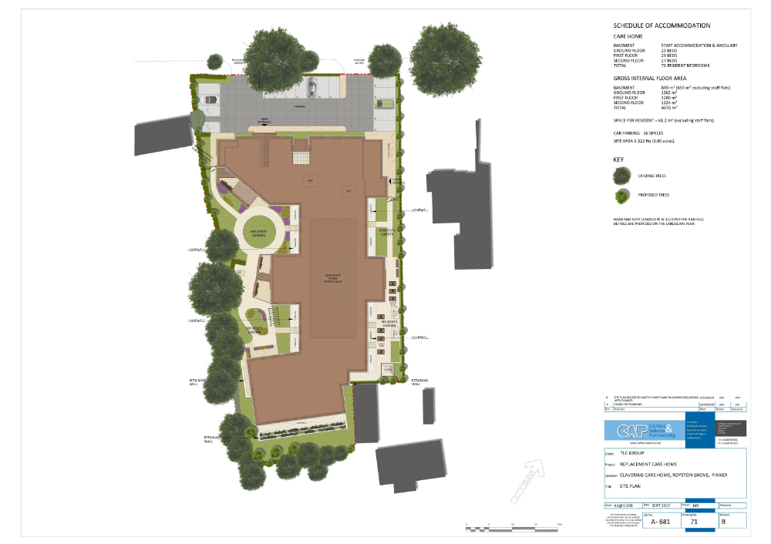

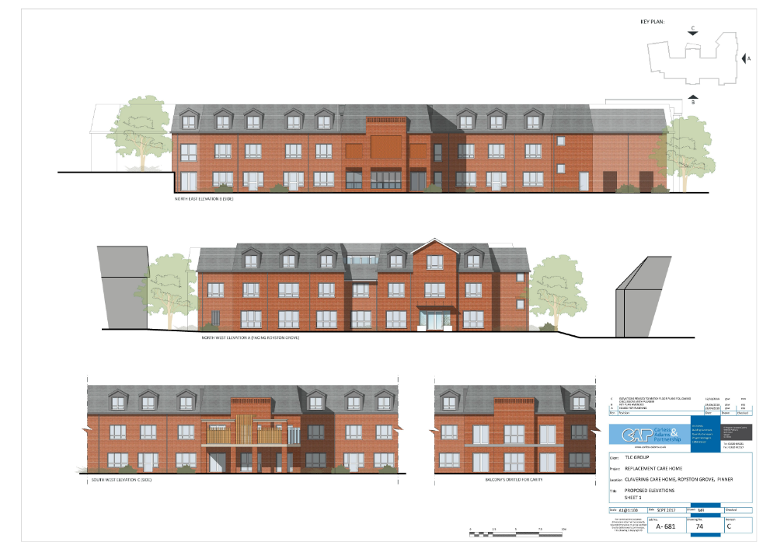
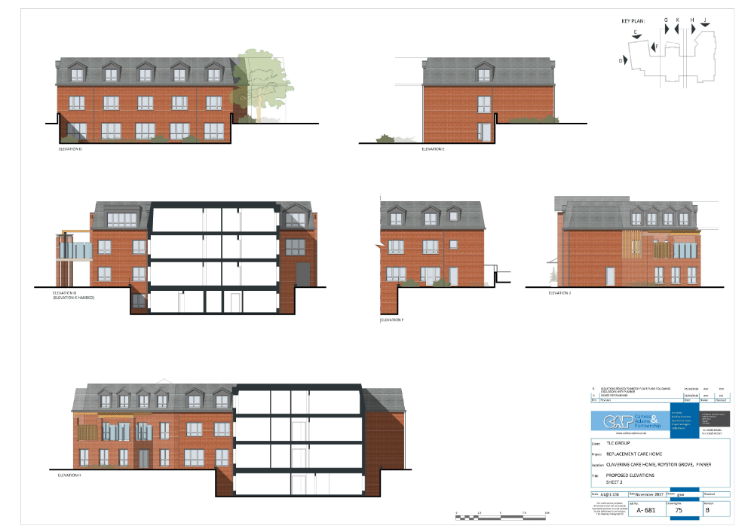
APPENDIX 3: SITE PHOTOGRAPHS

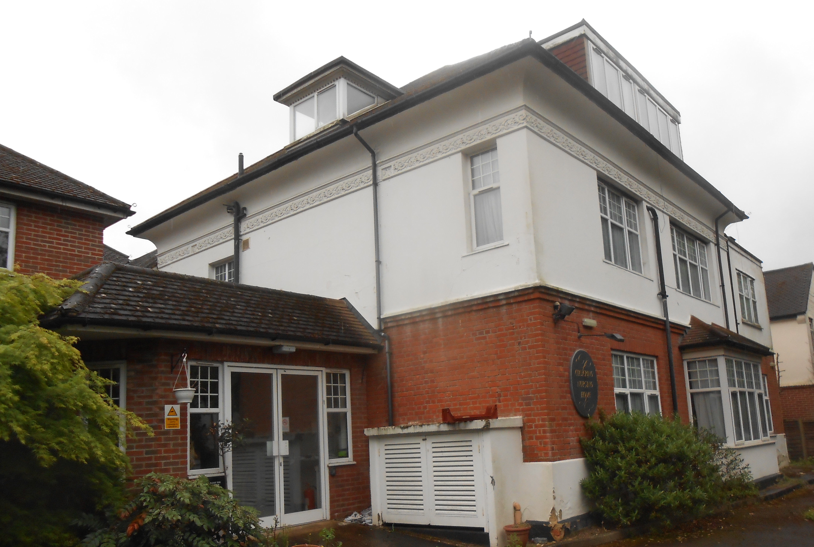

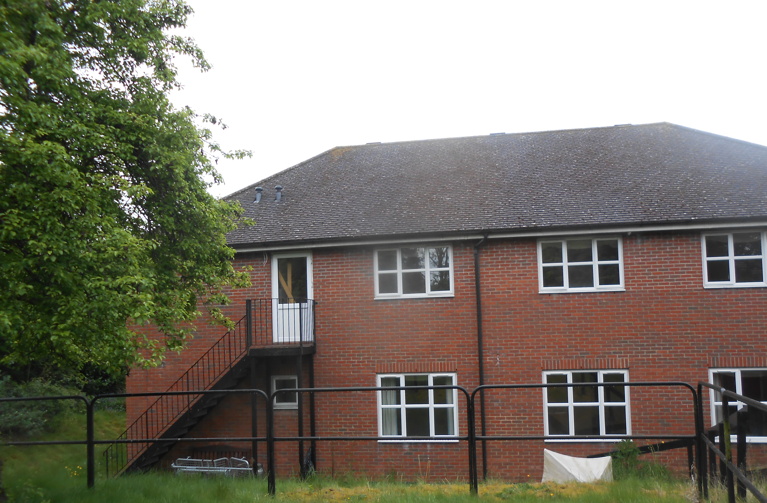

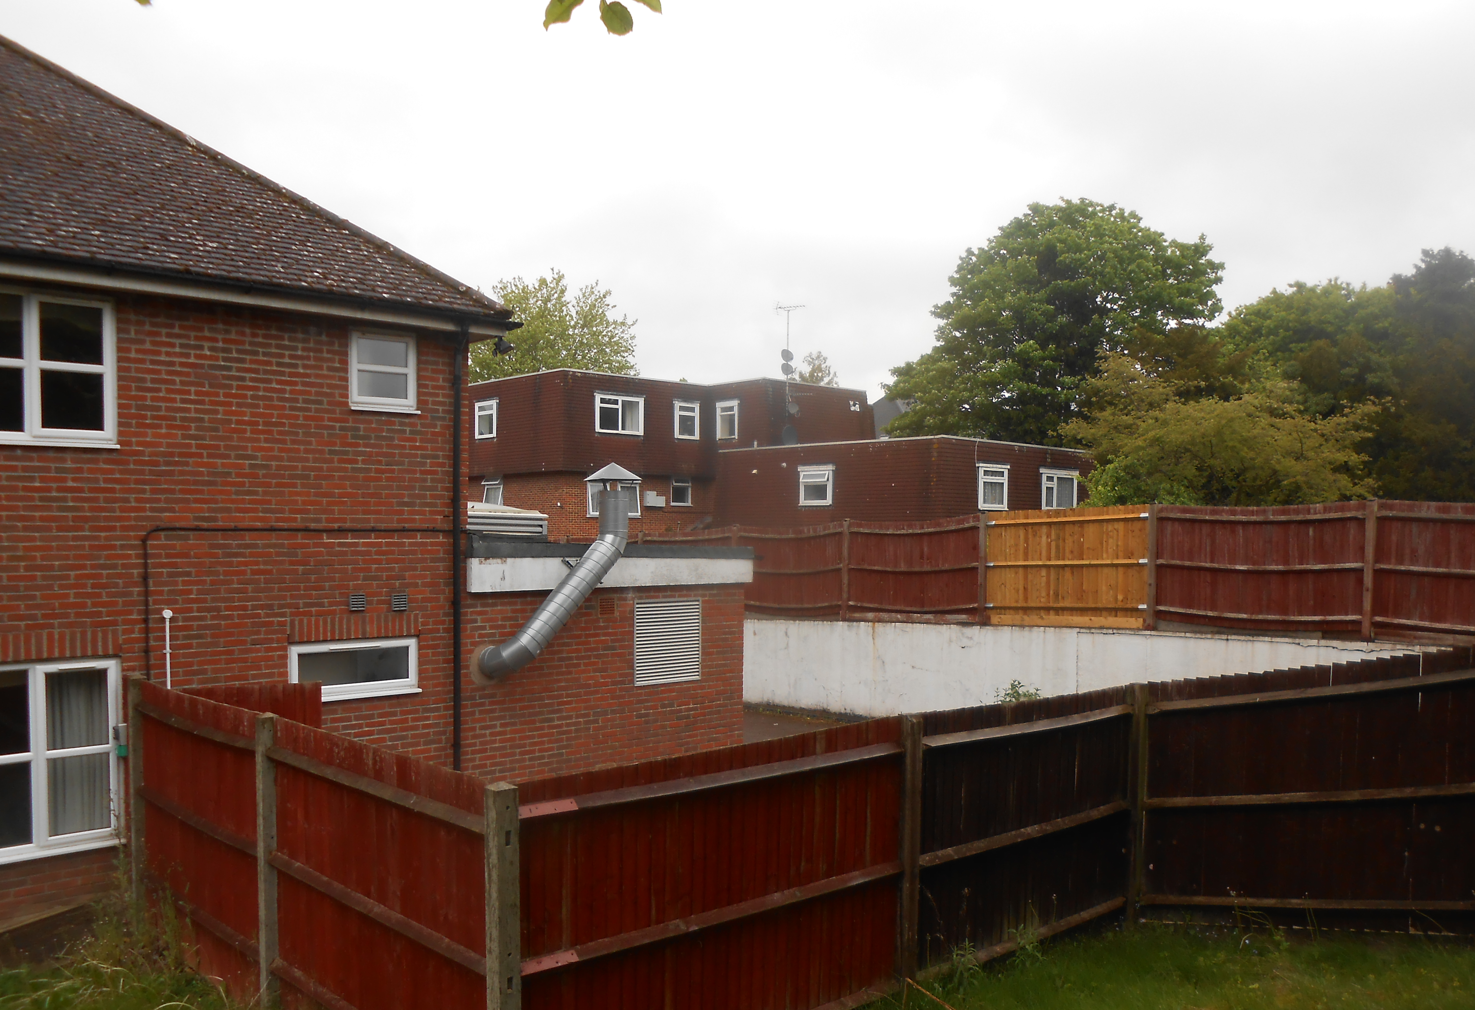

This page has been left intentionally blank

